

This short statistics report was prepared for demonstration by [*PaperAccepted.net*](https://paperaccepted.net). All our reports follow the IMRaD structure, consisting of publication-ready methods and results. Please go to our website to see how we can help you get publishable results.

**Methods**

*Participants and setting*

     This was a prospective, single-center, non-interventional cohort study of patients with monoclonal gammopathy of undetermined significance (MGUS). We included newly diagnosed patients who agreed to take part in the study. The diagnosis of MGUS was made in accordance with the criteria of the International Myeloma Working Group. The study lasted from January 1986 to March 2022. Ethics approval was obtained from the local Ethics Committee. All patients signed informed consent before enrollment.

*Outcomes*

     The main outcomes were overall survival and conversion to plasma cell myeloma (PCM). Survival status and the date of death were taken from the Nationwide Electronic Registry of the Ministry of Internal Affairs. Patients were assessed for conversion to PCM every 12 months or when clinically indicated. PCM was diagnosed when the concentration of monoclonal protein in serum was 3 g/dl or greater. We compared overall survival and conversion to PCM depending on the concentration of monoclonal protein in serum (M spike) at diagnosis, i.e., between patients with M spike concentrations above the median for the overall cohort (high M spike group) or below the median (low M spike group).

*Statistical analyses*

     Baseline characteristics were analyzed descriptively and compared between the high and low M spike groups with the Wilcoxon rank sum test or the Chi-squared test. Overall survival was analyzed with Kaplan-Meier curves and was compared between the two groups with the log-rank test. A competing risk approach was used to analyze the rate of conversion to PCM, with death as a competing event. The cumulative incidence curves of conversion to PCM were compared between the high and low M spike groups with the Gray’s test. Survival rates and the rates of conversion to PCM were calculated at 5-year intervals from the diagnosis of MGUS. We used multivariate regression analyses to investigate the predictors of overall survival (Cox proportional hazards model) and of conversion to PCM (Fine-Gray subdistribution hazard model). Hazard ratios (HR) with 95% confidence interval (CIs) were calculated for the following predictors: baseline M spike concentration (high vs. low), sex, age, and hemoglobin and creatinine concentrations. The R software (v. 4.2.2) was used for all calculations. P-values < 0.05 were considered statistically significant.

**Results**

*Cohort characteristics*

     Of 1532 patients assessed for eligibility, 13 did not agree to take part, 118 already had PCM, and 28 were lost to follow-up (Fig. 1. shows patient selection). In total, we included data of 1373 patients with MGUS (54% male), at a median age of 72 years at diagnosis. Patients with high or low M spike concentrations did not differ significantly in baseline characteristics (see Tab. 1. for details). The median (interquartile range) duration of follow-up was similar in the two groups; low M spike group: 6.9 (3.4, 11.4) years, high M spike group: 7.1 (3.3, 12.1) years; p = 0.305.

*Outcomes*

     Over a follow-up of 10999 person-years, 957 (69.7%) patients died, and 115 (8.38%) developed PCM. Overall survival did not differ significantly between the high and low M spike groups (p = 0.509, see Fig. 2A.). The median survival (95% CI) was 8.1 (7.3, 8.8) years in the low M spike group and was 8.2 (7.6, 9.2) years in the high M spike group (see supp. Tab. S1. for survival rates at 5-year intervals from diagnosis of MGUS). The Cox proportional hazards regression showed that the risk of death was increased in older patients (HR = 1.06 [95% CI: 1.05 - 1.06]), men (HR = 1.58 [1.38 - 1.80]), and patients with lower hemoglobin concentrations (HR = 0.88 [0.85 - 0.91]) and greater creatinine concentrations at diagnosis of MGUS (HR = 1.05, [1.01 - 1.09]; see Tab. 2. for details).  
    Conversion to PCM was significantly more frequent in the high M spike group than in the low M spike group: 78 (12.4%) vs. 37 (4.96%) patients (p < 0.001, Fig. 2B.; supp. Tab. S2.). In the multivariate regression analysis, significant predictors of conversion to PCM included high M spike concentrations (HR = 2.52, [95% CI: 1.70 - 3.73]) and younger age (HR = 0.98, [0.97 - 1.00]; see Tab. 2. for details).

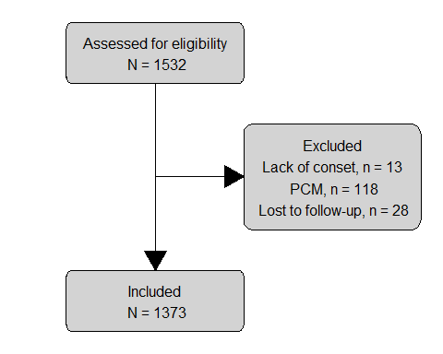

**Figure 1.** Flowchart of patient selection. PCM, plasma cell myeloma.

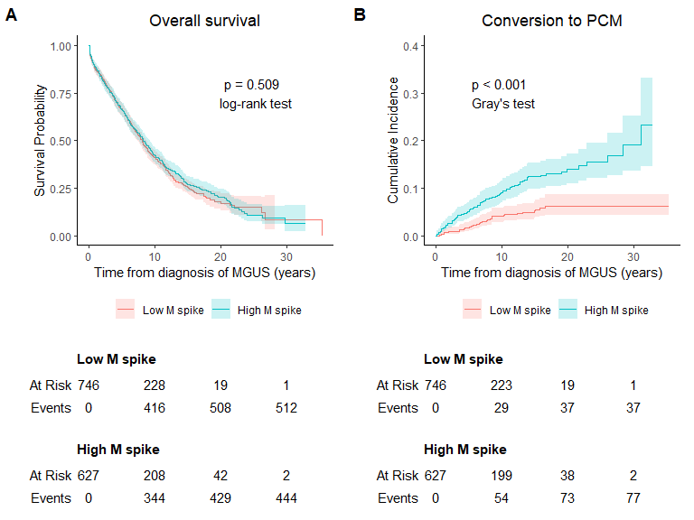

**Figure 2.** Overall survival (A) and conversion to plasma cell myeloma (B) from diagnosis of monoclonal gammopathy of undetermined significance. Ribbons show 95% confidence intervals. Low M spike, patients with baseline monoclonal protein concentrations below median; high M spike, patients with baseline monoclonal protein concentrations above median; PCM, plasma cell myeloma

**Table 1.** Baseline characteristics at diagnosis of MGUS

| Characteristic | Overall, N = 1,3731 | Low M spike, N = 7461 | High M spike, N = 6271 | p-value2 |
| --- | --- | --- | --- | --- |
| Age (years) | 72 (63, 79) | 72 (63, 79) | 72 (63, 79) | 0.874 |
| Sex |  |  |  | 0.293 |
| Female | 627 (46%) | 331 (44%) | 296 (47%) |  |
| Male | 746 (54%) | 415 (56%) | 331 (53%) |  |
| Hemoglobin (g/dl) | 13.50 (12.20, 14.70) | 13.60 (12.20, 14.70) | 13.50 (12.20, 14.80) | 0.537 |
| Creatinine (mg/dl) | 1.10 (0.90, 1.30) | 1.10 (0.90, 1.30) | 1.10 (0.90, 1.30) | 0.632 |
| M spike (g/dl) | 1.20 (0.60, 1.50) | 0.70 (0.50, 1.00) | 1.60 (1.40, 1.80) | **<0.001** |
| 1Median (IQR); n (%) | | | | |
| 2Wilcoxon rank sum test; Pearson's Chi-squared test | | | | |

IQR, interquartile range; Low M spike, patients with concentrations of monoclonal protein at diagnosis below the median value for the overall cohort; High M spike, patients with concentrations of monoclonal protein at diagnosis above the median value for the overall cohort. MGUS, monoclonal gammopathy of undetermined significance.

**Table 2.** Predictors of death and conversion to PCM in multivariate regression models

|  | Death | | | PCM | | |
| --- | --- | --- | --- | --- | --- | --- |
| Characteristic | HR1 | 95% CI1 | p-value | HR1 | 95% CI1 | p-value |
| M spike at diagnosis of MGUS |  |  |  |  |  |  |
| Low M spike | — | — |  | — | — |  |
| High M spike | 1.05 | 0.92, 1.20 | 0.440 | 2.52 | 1.70, 3.73 | **<0.001** |
| Age (years) | 1.06 | 1.05, 1.06 | **<0.001** | 0.98 | 0.97, 1.0 | **0.005** |
| Sex |  |  |  |  |  |  |
| Female | — | — |  | — | — |  |
| Male | 1.58 | 1.38, 1.80 | **<0.001** | 0.87 | 0.59, 1.28 | 0.470 |
| Hemoglobin (g/dl) | 0.88 | 0.85, 0.91 | **<0.001** | 0.96 | 0.87, 1.05 | 0.370 |
| Creatinine (mg/dl) | 1.05 | 1.01, 1.09 | **0.009** | 0.71 | 0.46, 1.12 | 0.140 |
| 1HR = Hazard Ratio, CI = Confidence Interval | | | | | | |

Cox proportional hazards regression was used to analyzed predictors of death. Fine-Gray subdistribution hazard model was used to study predictors of conversion to PCM. Low M spike, patients with concentrations of monoclonal protein at diagnosis below the median value for the overall cohort; High M spike, patients with concentrations of monoclonal protein at diagnosis above the median value for the overall cohort; MGUS, monoclonal gammopathy of undetermined significance; PCM, plasma cell myeloma.

**Supplemental material**

**Table S1.** Survival rates from diagnosis of MGUS

| Follow-up | Low M spike | High M spike |
| --- | --- | --- |
| 5 years | 67% (63%, 70%) | 66% (62%, 70%) |
| 10 years | 41% (38%, 45%) | 42% (38%, 46%) |
| 15 years | 25% (22%, 29%) | 27% (23%, 31%) |
| 20 years | 17% (13%, 22%) | 20% (17%, 25%) |
| 25 years | 15% (11%, 21%) | 11% (7.3%, 16%) |
| 30 years | 8.3% (3.3%, 21%) | 6.4% (2.5%, 16%) |

Values show percentages of surviving patients (95% confidence intervals). Low M spike, patients with concentrations of monoclonal protein at diagnosis below the median value for the overall cohort; High M spike, patients with concentrations of monoclonal protein at diagnosis above the median value for the overall cohort; MGUS, monoclonal gammopathy of undetermined significance.

**Table S2.** Conversion to PCM from diagnosis of MGUS

| Follow-up | Low M spike | High M spike |
| --- | --- | --- |
| 5 years | 1.9% (1.1%, 3.1%) | 5.3% (3.7%, 7.2%) |
| 10 years | 4.2% (2.8%, 5.8%) | 9.1% (6.9%, 12%) |
| 15 years | 5.5% (3.9%, 7.6%) | 12% (9.8%, 15%) |
| 20 years | 6.3% (4.4%, 8.6%) | 14% (11%, 17%) |
| 25 years | 6.3% (4.4%, 8.6%) | 16% (12%, 20%) |
| 30 years | 6.3% (4.4%, 8.6%) | 19% (14%, 25%) |

Values show percentages of patients developing PCM (95% confidence intervals). Low M spike, patients with concentrations of monoclonal protein at diagnosis below the median value for the overall cohort; High M spike, patients with concentrations of monoclonal protein at diagnosis above the median value for the overall cohort; MGUS, monoclonal gammopathy of undetermined significance; PCM, plasma cell myeloma.